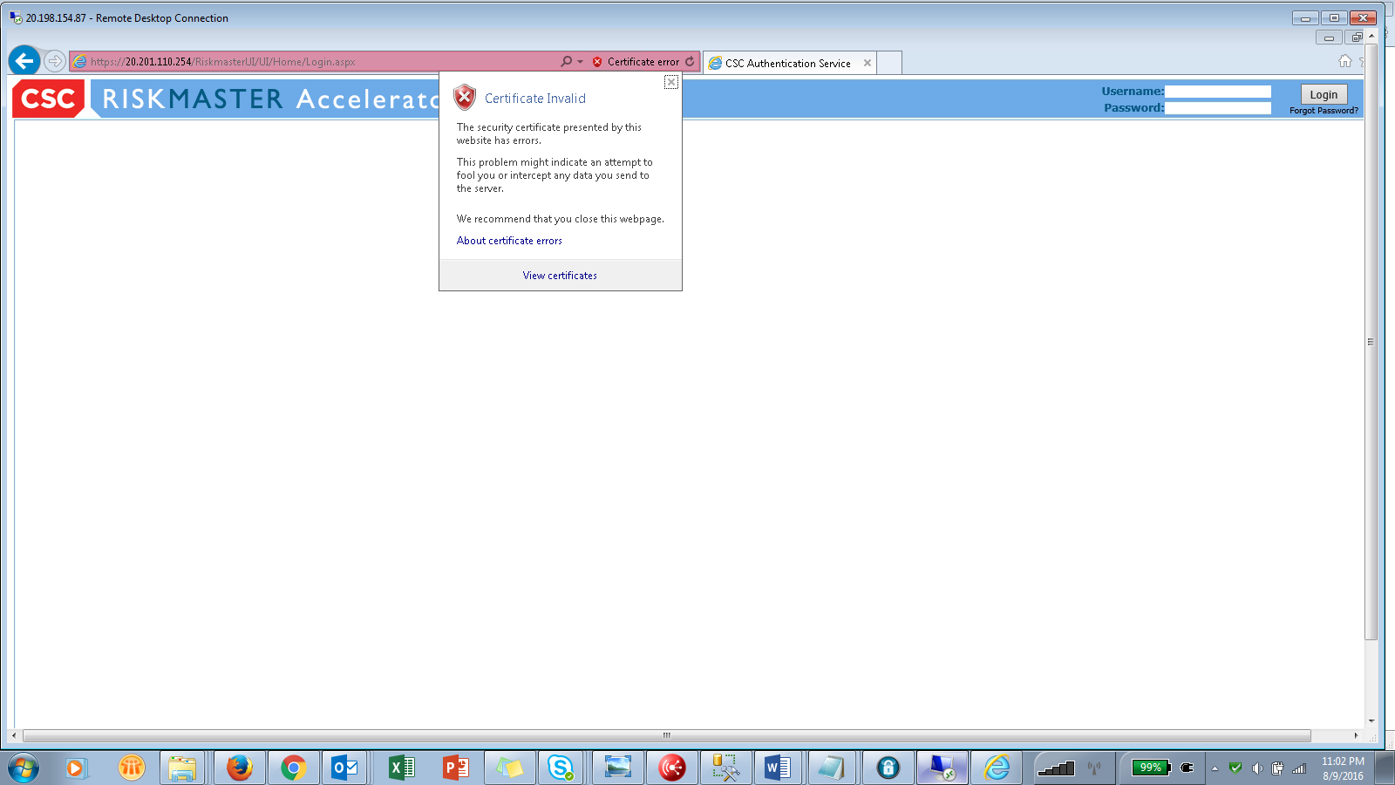

Click View Certificates. View the message in ‘General’ tab- Certificate Information

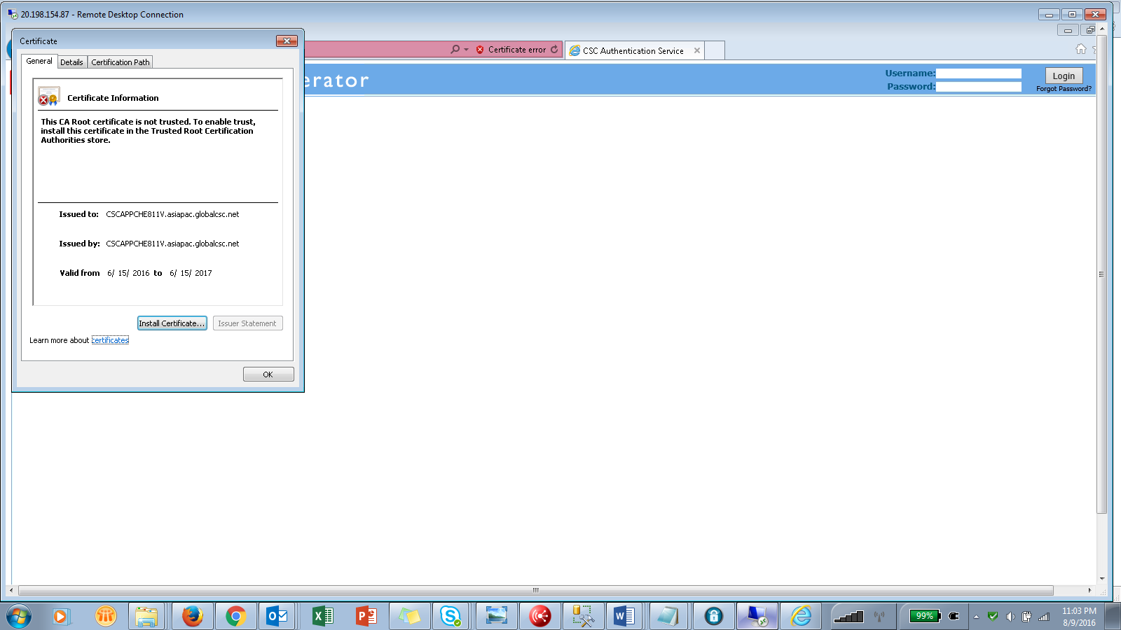

Click Install Certificate

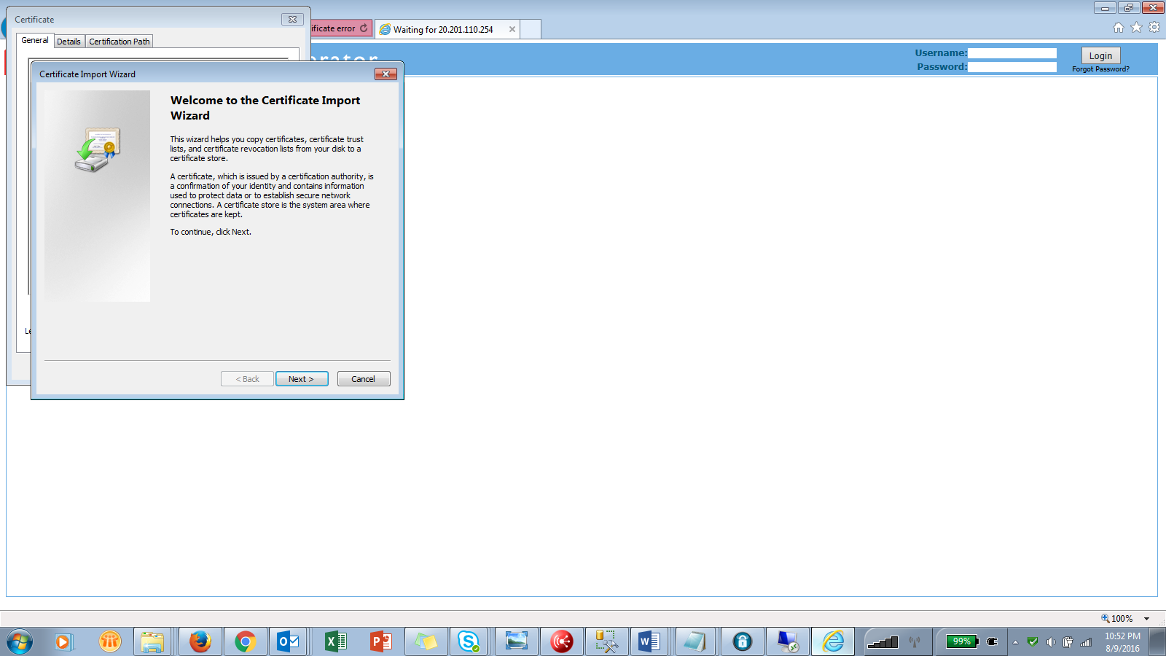

Click Next

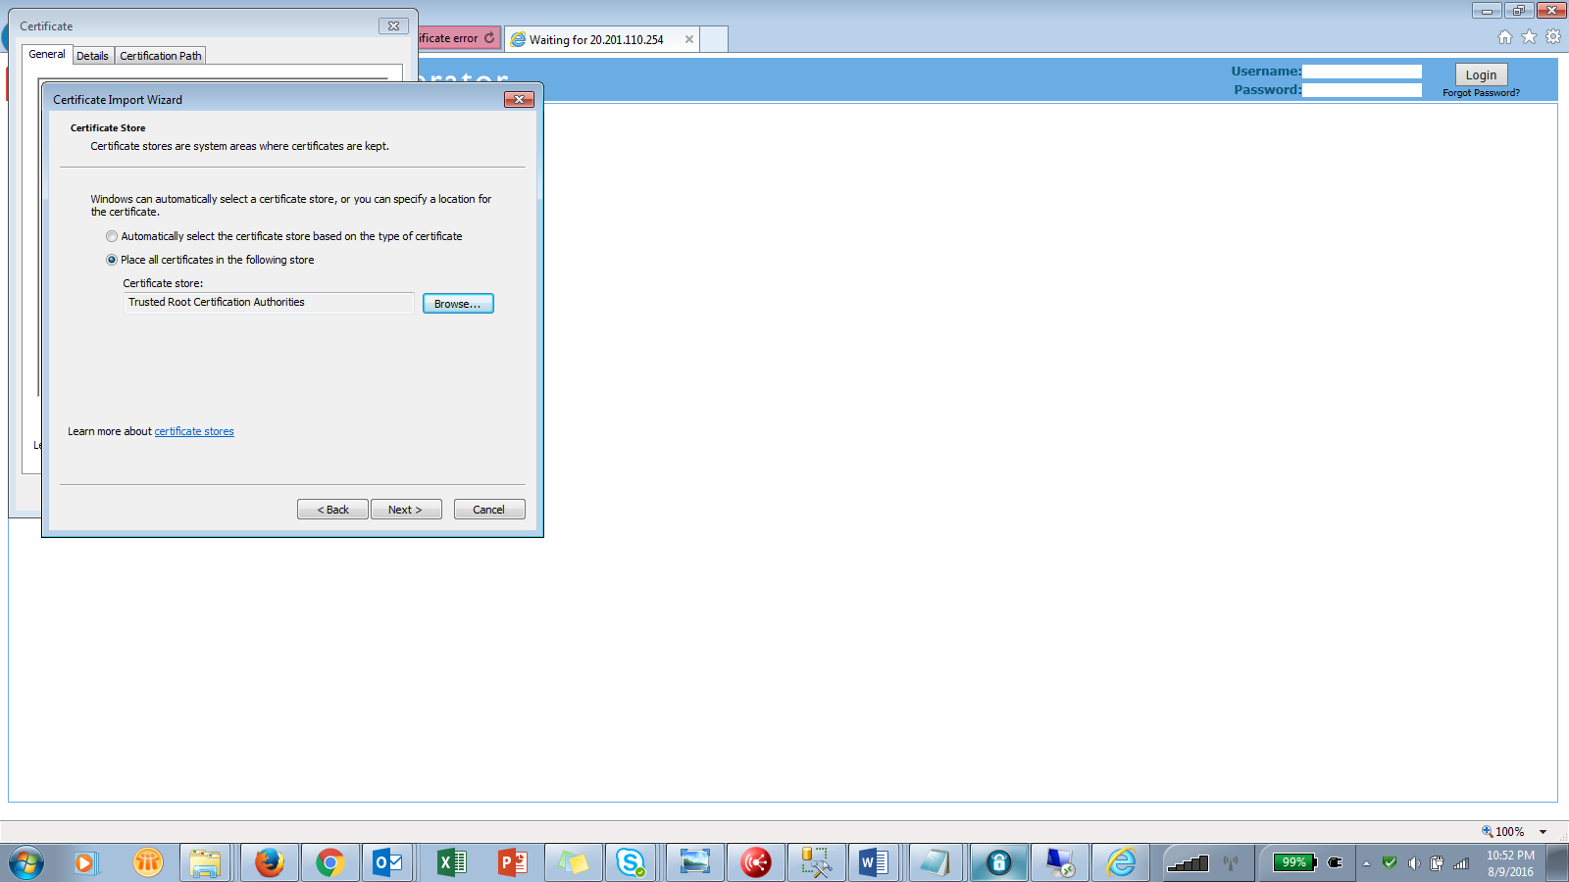

Select ‘Place all certificates in the following store’ radio button & Browse for ‘Trusted Root Certification Authorities’

Click Next

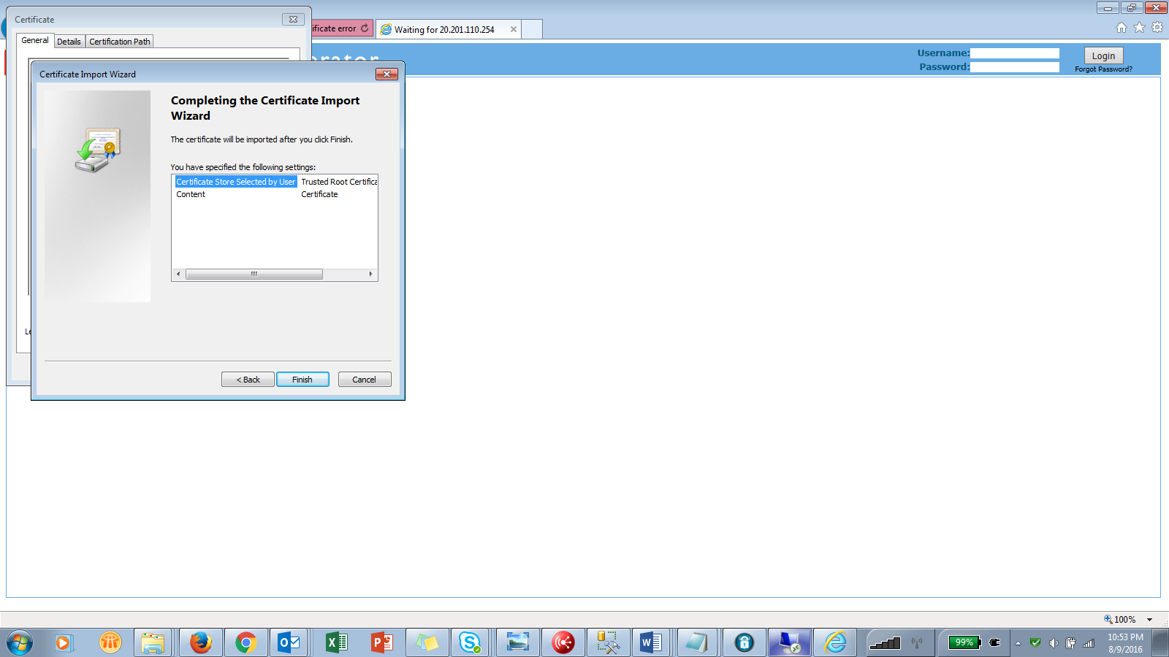

Click Finish. Below pop up will displayed. Click Yes

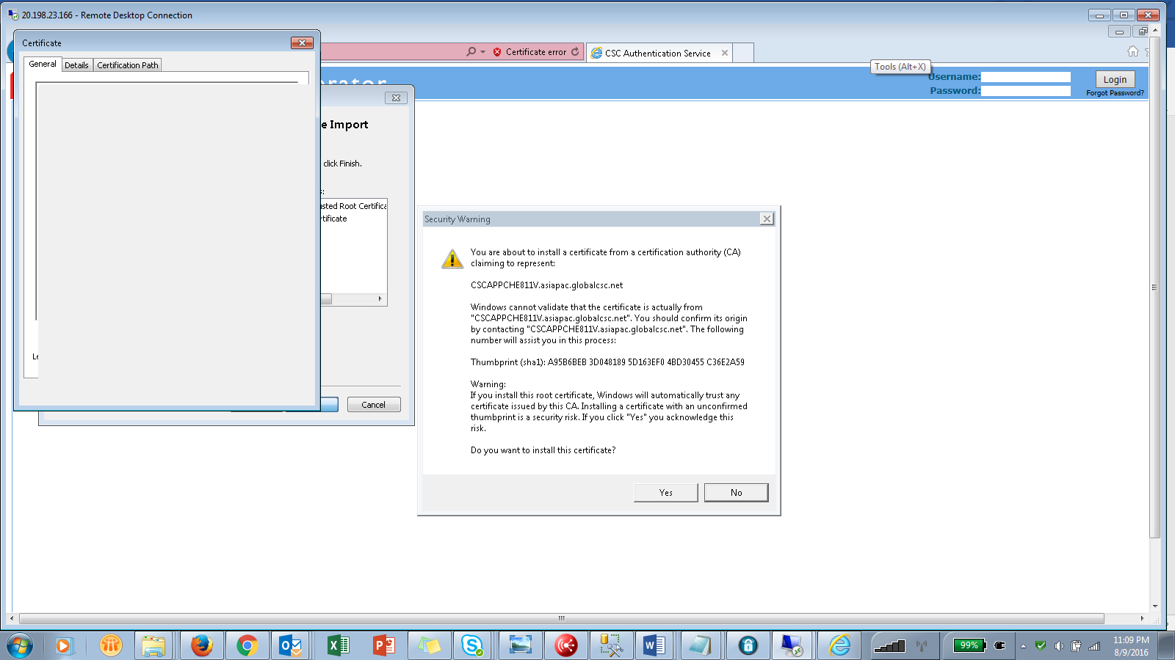

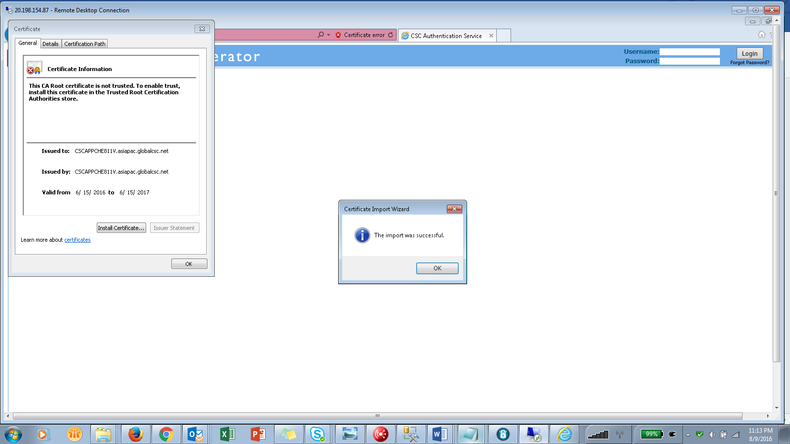

Click Ok.

Close Browser. Launch the URL with https again & Click View Certificate.

Verify under ‘General’ tab – Certificate Information- that the message has changed.

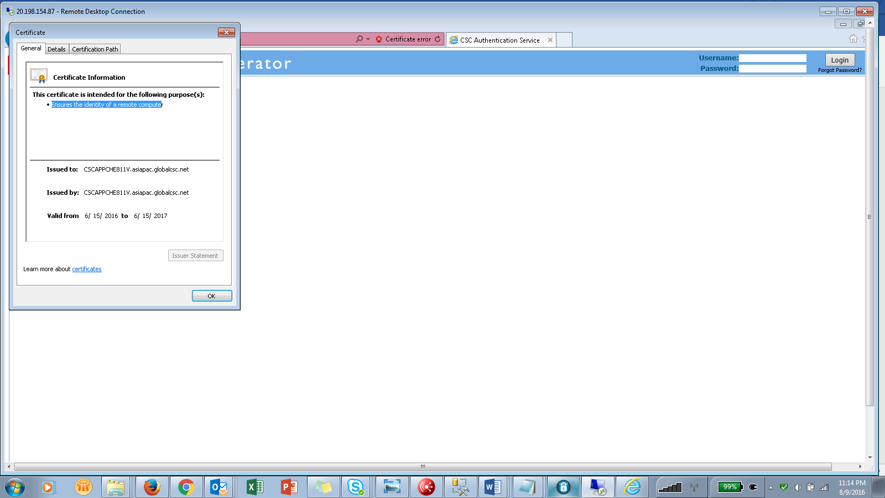

Verify under ‘Certification Path’ tab- ‘Certificate Status’ says – The Certificate is OK.

